**MEMBERSHIP APPLICATION**

------------------------------------------

(Applicants Name)

MARTHASVILLE  
Fire Protection District

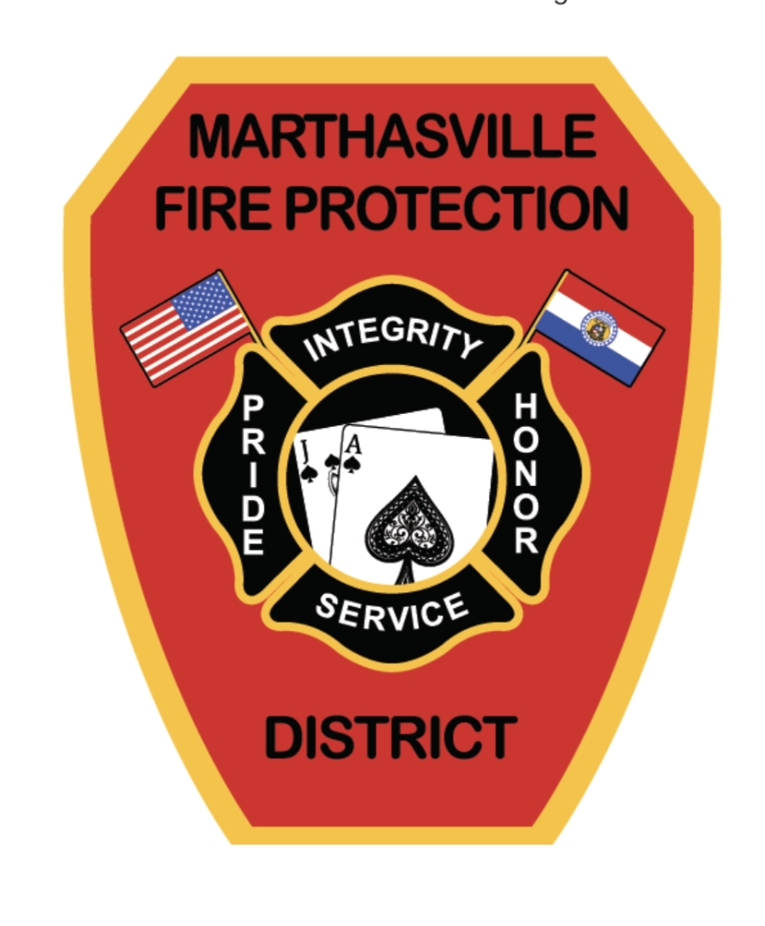

405 East Main St. ♦ Marthasville, Missouri 63357 ♦ 636-433-2240

www.Marthasvillefire.org

**PERSONAL**

Failure to provide information on this form could delay the processing of your application.

|  |  |  |  |  |  |
| --- | --- | --- | --- | --- | --- |
| Last Name: | Firs Name First: | | Middle: | | Date: |
| Street Address: | | | | | Home Phone: |
| City: | | State: | | Zip: | Business Phone: |
| Social Security Number: | | Sex: | | | Mobile Phone: |
| Are you over 18 years of age: | Date of Birth: | Are you a US citizen? | | | Pager: |
| How did you learn about our organization? | | | | | E-Mail Address: |
| Have you applied here before: |
|  | | | | | |
| **EXPERIENCE**   |  | | --- | | Have you ever previously been a member of a Fire/Rescue department? Yes No  If so, which department(s) and how long: | | Have you ever been denied membership to any Fire/ Rescue department or other volunteer org? Yes No  If so, explain: | | Have you ever been discharged, asked to leave, or resign from any fire dept. or volunteer org? Yes No  If so, explain: | | List any Fire or EMS certifications: Can you provide certificates? Yes No  Certifications State Expiration  _____________________________ __________ _________________________________  _____________________________ ___________ _________________________________  _____________________________ ___________ _________________________________  _____________________________ ___________ _________________________________  _____________________________ ___________ ________________________________ | | List any other trainings or certifications relevant to the Marthasville Volunteer Fire Department. | | **EDUCATION**   |  |  |  |  |  |  | | --- | --- | --- | --- | --- | --- | | TYPE | Name and Location of School | Course Study | # Years | Graduate | Degree | | High School |  |  |  |  |  | | College |  |  |  |  |  | | Other |  |  |  |  |  |   **EMPLOYMENT**   |  |  |  |  | | --- | --- | --- | --- | | Present Employer: | | | Telephone Number: | | Address: | | | Name of Supervisor: | | Start Date: | | End Date: | May we Contact: Yes No | | Job Title and Work Description: | | | | | Previous Employer: | | | Telephone Number: | | Address: | | | Name of Supervisor: | | Start Date: | End Date: | | Reason for Leaving: | | Job Title and Work Description: | | | |  REFERENCES List three references, ***not*** related to you, that have known you for at least two years.   |  |  |  |  |  | | --- | --- | --- | --- | --- | | Name | Relation | Phone Number | Best Time to call | Years Known | |  |  |  |  |  | |  |  |  |  |  | |  |  |  |  |  | | | | | | | |

**EMERGENCY CONTACT**

|  |  |  |  |  |
| --- | --- | --- | --- | --- |
| Name: | | | Relation: | |
| Address: | Home Phone: | | | Mobile Phone: |
| City: | State | Zip | | Work Phone: |

**GENERAL INFORMATION**

|  |
| --- |
| Why do you want to volunteer? |
| How would the department benefit from you becoming a member? |
| Have you ever been convicted of a moving violation, misdemeanor, or felony? Yes No  If yes explain: |
| Are you currently under any pending indictment or charge? Yes No  If yes explain: |
| Do you have any medical issues, health concerns, or physical disabilities? Yes No  If yes explain: |
| |  | | --- | | I hereby certify that the information contained herein is true, accurate, and complete to the best of my knowledge. I understand that should any information provided, or by omission, prove false, misleading, or erroneous my applications may be delayed or rejected. I further certify that any information given under false pretense could lead to my immediate dismissal from the Marthasville Volunteer Fire Department should I be accepted into membership. I also authorize the Marthasville Volunteer Fire Department to conduct a criminal background check to verify my answers to the previous questions.  ____________________________________ _________________________  Signature of Applicant Date  **Applicants will be contacted by phone upon verification of the supplied information by a member of the applicant review committee.**  **The Marthasville Volunteer Fire Department is an Equal Opportunity Volunteer Organization that does not discriminate for membership on a basis of sex, race, color, creed, national origins, religious beliefs, sexual orientation, employment status, or marital status. Please contact the Fire Chief for further details and information on Membership requirements and By Laws of the Marthasville Volunteer Fire Department.** | | **This section is to be completed by the legal guardian of applicants under age 18**  I hereby certify that I am the Parent or Legal Guardian of the Applicant and the above named individual has my permission to apply for membership and participate in Fire and Rescue activities with the Marthasville Volunteer Fire Department although he or she is under the age of 18 at the time.  __________________________________________ ________________________  Signature of Parent or Legal Guardian Date | |

District Use Only:

Received By:__________________ Date:_________________